Automatic Speech Recognition

Project Automatic Speech Recognition for Telugu
Faculty Dr. Anil Kumar Vuppala
Mentor Ganesh Mirishkar
Campus IIIT - Hyderabad

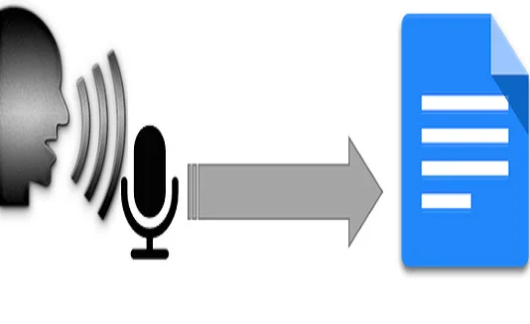

Group1 Team Members
Vijay Bhasker
Varsha Loya Ravathkar
Pravalika Kommagouni
Myla Mahojjwal
Varma MRKS

Table of contents… 2
Abbreviations 3
  - Introduction ………………………………………………………. 3
1.1 Background ……………………………………………………. 4
1.2 Problem Statement ……………………………………………… 4
1.3 Objectives ………………………………………………………. 4
1.4 Literature Review ………………………………………………. 4
2. Methodologies ………………………………………………………. 5
3. Telugu ASR system using Kaldi toolkit ……………………………. 5
3.1 Data Preparation ………………………………………………... 6
3.2 MFCC …………………………………………………………... 6
3.3 Language Modelling …………………………………………… 8
3.4 Acoustic Modelling …………………………………………… 8
3.5 Decoding ………………………………………………………. 9
4. Inference …………………………………………………………… 10
4.1 Limitations …………………………………………………….. 11
4.2 Improvements …………………………………………………. 11
5. Conclusion ………………………………………………………… 11
6. Reference …………………………………………………………. 12

Abbreviations

ASR | Automatic Speech Recognition
TTS | Text-to-Speech
AM | Acoustic Modelling
LM | Language Modelling
HMM | Hidden Markov Model
GMM | Gaussian Mixture Model
WER | Word Error Rate
MFCC | Mel-frequency Cepstral Coefficients
FST | Finite State Transducers

- INTRODUCTION
1.1 Background
Telugu, being the one of the official languages of India, is the 4th most spoken language and 15th in the world in the Ethnologue list of languages by number of native speakers. With over 81 million native speakers as per the 2011 census, the prevalence of Telugu coupled with a small percent of Indians using English for communication and literacy makes the availability of a commercial grade automatic speech recognition system for the Telugu language necessary.

1.2 Problem Statement
Good quality ASR systems for Telugu, or any Indian language for that matter, that can be used for real time deployment are not available. Though a number of prototypes are created and research is being carried out, for Indian language systems such as Hindi and Telugu, none of these are of quality that can be compared to commercial grade ASR systems for languages like English, German and French. The primary reason for this is that developing any system for a new language needs huge amount of transcribed speech corpus for that language. Furthermore, we need close collaboration between linguists and computer scientists, for resolving language speciﬁc issues.
Such a large corpus must be collected from multiple speakers of varying regions such as Telangana, Andhra, Rayalaseema which has different dialects to adequately capture the diversity in a language and train the system well, allowing it to cope with any speaker, adapting to his/her style.

1.3 Objectives
Designing a web application, using HTML and Fast API, to effectively handle the audio files and their transcriptions, and performs collaborative human correction of the ASR transcripts. The web app is designed to operate in real-time, to take the speech input and submit it to API endpoint. Fast API provides automatic data validation to ensure the incoming audio data is in the correct format and meet the specific requirement such as sample rate and audio encoding. This involved specific recording of 16 kHz mono channel audio from any device hosting the web app, and performs voice activity detection to detect presence or absence of human speech and capturing some processes during non-speech intervals.
Collection of speech data and transcripts from 5 to 6 Telugu speakers to adapt and train the ASR model. Testing a neural network which functions to align with and map the speech signal to HMM states accurately.
Developing a lexicon model to generate phonemes from Telugu transcripts, adhering to language specific rules.

1.4 Literature Review
All areas of language and speech technology, directly or indirectly, requires handling of real (unrestricted) text including word segmentation using lexicon, text normalization and tokenization. The lexicon, which is collection of words and their pronunciation helps to segment the input speech signal into words.

The language models and acoustic models are built using the open source toolkit Kaldi. The various acoustic models used for the comparison of word error rates (WER) in Kaldi include HMM-GMM (Hidden Markov Model-Gaussian Mixture Model) based Monophone, Triphone (tri1,tri2, tri3) and SGMM(Sub Space Gaussian Mixture Model). Comparing the WER for various acoustic models used, it was observed that tri3 model has the least WER over the other acoustic models.

- Methodology
All speech processing applications, such as ASR and Text-to-speech, directly or indirectly, require handling of real (unrestricted) text. In order to manage the huge amounts of speech and text (transcript) data, a web application was designed using HTML code to effectively handle the audio files and their transcriptions, and performs collaborative human correction of the ASR transcripts. The web app implemented a Fast API, user needs to load all wav audio files from the local machine into the web app which would then present the user with the transcripts of the corresponding audio files in text format.
A web interface was created for speech recognition, which provided an user interface allowing users to record their voice and request the server to recognize and transcribe it to text. This involved specific recording of 16 kHz mono channel audio using headphone or speakers hosted locally. This was achieved by down-sampling the recorded data by omitting excess data points from the recorded speech vector. Speech files contains pauses or silence intervals. This inclusion of non-speech intervals in the speech files necessitates voice activity detection because these intervals do not contain any speaker information.
ASR requires a considerable amount of speech data to train its model. This required collection of Telugu speech samples from multiple speakers of different origins and dialects. The volunteers were required to speak out Telugu sentences into a microphone which recorded the audio in 16 kHz mono channel wave format. The volunteers were given transcripts containing 120 sentences written in Telugu out of which 6 meaningless sentences were common for all speakers (used for speaker adaptation by the system) and 114 meaningful sentences different for each speaker. The audio was recorded in a noise free environment with no stammering or fumbling made by the speakers, taking 45 minutes on an average per speaker. All speakers were above the age of 16 and mostly comprised of fluent Telugu speakers, with considerable data collected from Telugu professors and Telugu major students. This resulted in almost clean and good quality data which could be used by the ASR system for training and testing.

- Telugu ASR system using Kaldi toolkit
Building an ASR system using the Kaldi toolkit involves several pre-processing, data preparation and language modeling stages, along with creating various supporting files. Fig. 2 depicts the sequence of steps required to build an ASR system.

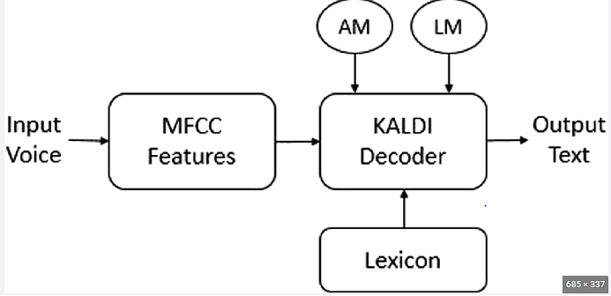
Fig2. Basic sequence of an ASR system

3.1. Data Preparation
A dataset of Test data of 6 hours, Train data of 53 hours and Dev data of 1 hour contributing to about 60 hours of data approximately at 16KHz, mono channel. We trained and tested our model on the Telugu datasets shared by Ganesh.
These segmented .wav files are divided into the test and train folders inside Kaldi directory. Transcription files described in Table 1 were created in both these folders.
Table 1. Few integral files for Kaldi ASR

3.2 Extraction of Mel-frequency Cepstral Coefficients (MFCC)

The next step after data preparation is feature extraction. The features to be extracted represent the phones within the words while other degrading factors in the signal such as the channel characteristics and the presence of noise in the background are suppressed. The commonly used feature extraction methods are MFCC and Perceptual Linear Prediction Coefficients (PLP). In our work we have used the MFCC feature extraction method, as depicted in Fig. 3.
The feature is extracted by applying a 25 ms Hamming window, with a 10ms overlap .The speech signals are sampled at 16 KHz .Thus, in one window about 400 samples are reduced to 13 cepstral coefficients. Further, additional delta and delta-delta coefficients can be added to the feature.
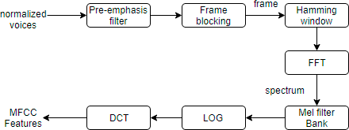
Fig 3. Block diagram of MFCC feature extraction procedure

Speech signals are not stationary. However, it can be assumed that they are stationary for a short span of time, i.e, for about 25 milliseconds. Therefore, a single feature vector from a speech signal is usually extracted over a 25 millisecond frame. For a smooth transition from frame to frame, the frames are 5 overlapped and shifted by 10 milliseconds (also known as stride). To avoid any noise that comes from the discontinuities at the edge of the frames, we use a window function such as a Hamming function Harris (1978) and multiply it by the time frames from which the features are extracted. The steps to extract MFCCs are as follows:
• Pre-Emphasis: The speech signal is passed through a high frequency filter. This helps in detecting phones better.
• Windowing: Hamming window function is applied on each frame in order to smooth the signal at the frame edges.
• Discrete Fourier Transform: This is done to move the signal from time domain to a frequency domain. This helps us analyse the amount of energy present in each frequency band better.
• Mel Filter Bank: This filter bank is inspired by the way humans perceive sounds and it has been shown that using this filter bank helps us extract robust features that help the ASR perform better. Human ears detect sounds at lower frequencies better than at higher frequencies. So the mel scale emulates the way humans hear by trying to map the actual frequencies to frequencies that humans perceive. The following is the mapping:
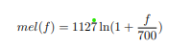
A log function is applied to the output of the mel filter as the function mimics how humans perceive sounds, i.e., humans are less sensitive to change at higher frequencies than at lower frequencies.
• Inverse Discrete Fourier Transform: This is done to move the signal from frequency domain back to time domain. It has been shown that the first 12 cepstrum coefficients carry most of the information required for the ASR to transcribe speech. As a result, for each frame 12 cepstrum coefficients are created and stored. Along with these 12 coefficients, the energy of each frame is also considered. The calculation of energy is done as follows:
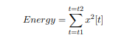
• Dynamic Features: We also consider the first order (∆) and second order (∆∆) derivatives of the 13 coefficients calculated so far. This gives an extra 26 coefficients. So in total, for each frame, we calculate 39 coefficients and this will be given as input to our speech recognition model

3.3 Language Modelling (LM)

For the conversion of words to phoneme sequences, a dictionary has been created using the English script as symbol representations. Each phoneme in Telugu is represented by a unique combination of symbols and letters in the English script. Aside from the phonemes, an additional silence phoneme, ’sil’ is added to represent the silence between hyphenated words or the start or end of a sentence as shown in Fig

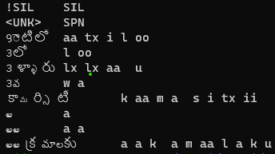
Fig:3.3.1. Snippet of lexicon file

3.4 Acoustic Modelling (AM)
Speech signals are composed of a sequence of phonemes. It is these phonemes that the Acoustic Model (AM) predicts from the feature vectors extracted as explained in Section 2.1.1. Multiple con secutive frames together make up a single phoneme. Therefore, we have to model the classification of the frame based on the previous frames. This is done using Hidden Markov Models (HMM) Gales and Young (2008). The sound in each frame is predicted by the emission distribution, which is most commonly estimated by Gaussian Mixture Models (GMM). Figure 2.1 shows an HMM phone predictor.

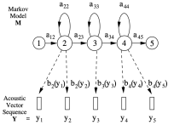

Figure 3.4.1: HMM-based Phone Predictor Young (1996).
HMM are chain states (both hidden and observable). The probability of transitioning from hidden state i to hidden state j is represented by aij , which is also known as transition probability. The likelihood of hidden state i emitting observable state j is represented by bij , which is also known as emission probability. It is important to note that the HMMs have self-loops, which allow us to model variable length of the phones.
While the emission distributions were commonly estimated by GMMs, recent advances in neural networks have allowed us to use them to estimate more complex functions.

3.5. Decoding
Kaldi’s decoding algorithm uses Weighted Finite State Transducers (WFSTs). The WFSTs provide graph operations, used in acoustic modeling. These decoding graphs are assigned numerical values corresponding to context-dependent states, called pdf-ids. As different phones can have the same pdf-ids, “transition-ids” are used which encode the pdf-ids of phone member and use arc (transition) within the topology specified for that phone. Thus, decoding is performed on these decoding graphs (HCLG) which is constructed from simple FST graphs.
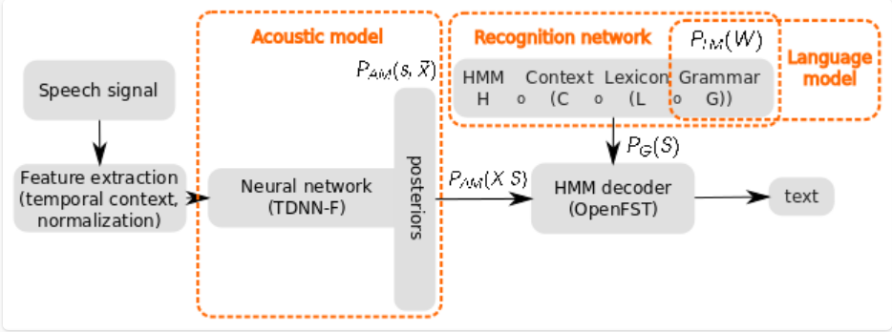
Fig: 3.5.1 Kaldi decoding model

The symbol ◦ represents an associative binary operation of composition on FST. HLGC is based on H- for HMM definitions, L for Language Models, G is the acceptor, which is used to encode the grammar and C, the context dependency.

- Inference
We have tested more than 30 plus instances of live recordings and decoded the output to text format as per the below given figure 4.1. In these instances, we have covered:
- Male and female voice
- Sentences with more complex words
- Sentences with foreign languages other than Telugu such as English and Hindi
- Recordings from database

Fig:4.1 Inference data

  - Limitations
- High accuracy rate observed when the input is recorded using mic/headphones with no background noise or disturbance.
- Miss cases occurred for words uttered in other than Telugu language.
- Miss cases observed for rapid talking also.
- Encoding is limited for only 15 secs.
  - Improvements
- More training and updating the Lexicon with more words
- Re-training for foreign languages and dialects
- Good pauses between words increases accuracy

- Conclusion
Speech recognition technology which is an increasingly popular concept in recent years attracts attention from organizations to individuals; the technology being widely used for the various advantages it provides. It brings the ability for a machine to listen and understand what people are talking or what user are commanding. The research and implementation of an entire speech recognition model for the Telugu language provided great insight into the technology and future scope for research. Also, the web app was successfully used to generate transcripts by given datasets and the web interface appropriately recorded and displayed speech transcripts that were recognized by the system.

References
- Daniel Povey, Arnab Ghoshal, Gilles Boulianne, Lukas Burget, Ondrej Glembek, Nagendra Goel, Mirko Hannemann, Petr Motlicek, Yanmin Qian, Petr Schwarz, et al. 2011. The kaldi speech recognition toolkit. In IEEE 2011 workshop on automatic speech recognition and understanding, CONF. IEEE Signal Processing Society
- Leveraging Language Relatedness to Improve Language Models in Speech Recognition Systems by Aditya Yadavalli, IIIT-H, Nov 2022
- Kaldi recipe in Hindi for word level recognition and phoneme level transcription by Karra Venkata Lakshmi Sri, Mayuka Srinivasan, Radhika Rajeev Nair, K. Jeeva Priya,Deepa Gupta- Department of Electronics and Communication Engineering, Amrita School of Engineering, Bengaluru, Amrita Vishwa Vidyapeetham, India
- https://www.prnewswire.com/in/news-releases/speech-and-voice-recognition-market-to-rise-exponentially-at-a-cagr-of-19-8-cloud-based-segment-to-emerge-dominant-says-fortune-business-insights-828795577.html
- https://www.atco2.org/news/automatic-speech-recognition-how-it-works

